

Foundations of Programming

Assignment No.: 14
PROBLEM STATEMENT: Write a C program to input a binary number from the user and convert it into a decimal number.

OBJECTIVE:

- To understand number system conversions.
- To learn how to convert binary numbers to decimal numbers in C.
- To practice the use of loops and arithmetic operations.
- To develop logical thinking for number system problems.

THEORY:
A binary number system uses only two digits: 0 and 1. Each digit of a binary number represents a power of 2 depending on its position. To convert a binary number into its decimal equivalent, each digit is multiplied by 2 raised to the power of its position and the results are added together. In C programming, this conversion can be implemented using loops and arithmetic operations.

PLATFORM: Linux
CODE:
#include <stdio.h>

int main() {
long long binaryNumber, temp;
int decimalNumber = 0, base = 1, remainder;

// Accept the binary number from the user
printf("Enter a binary number (0s and 1s): ");
scanf("%lld", &binaryNumber);

// Store the original number in a temporary variable for processing
temp = binaryNumber;

// Loop to extract digits and convert to decimal
while (temp > 0) {
remainder = temp % 10; // Extract the rightmost digit
decimalNumber += remainder * base; // Add the weighted value to the decimal total
temp = temp / 10; // Remove the rightmost digit
base = base * 2; // Update the base (powers of 2: 1, 2, 4, 8, 16...)
}

// Display the result
printf("The decimal equivalent of %lld is: %d\n", binaryNumber, decimalNumber);

return 0;
}
INPUT AND OUTPUT:
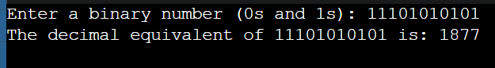

CONCLUSION: Thus, the C program successfully converts a binary number entered by the user into its decimal equivalent using loops and arithmetic operations.

